**DESIGNING A MODEL FOR SUICIDAL BEHAVIOUR DETECTION USING MACHINE LEARNING**

|  |
| --- |
| **A Project Report Submitted** |
| **In Partial Fulfillment of the Requirements** |
| **for the Degree of** |
|  |
| **B. TECH.** |
| **in** |
| **ARTIFICIAL INTELLIGENCE** |
|  |
| **by** |
|  |
| **PRATEEK KUMAR SINGH (2001331520083)** |
| **RITIKA SINGH (2001331520083)**  **SHADIYA KHAN (200133520083)** |
|  |
| **Under the Supervision of**  **Barkha Bhardwaj**  **Designation, Department** |
|  |
| **NOIDA INSTITUTE OF ENGINEERING AND TECHNOLOGY**  **(An Autonomous Institute of AKTU, Lucknow)** |
| Home AKTU Final Year Exams 2021 Semester Date Sheet Released ... |

|  |
| --- |
| **to the** |
| **Faculty of Artificial Intelligence** |
| **DR. A.P.J. ABDUL KALAM TECHNICAL UNIVERSITY** |
| **(Formerly Uttar Pradesh Technical University, Lucknow)** |
| **May, 2024** |

# DECLARATION

I hereby declare that the work presented in this report entitled “**DESIGNING A MODEL FOR SUICIDAL BEHAVIOUR DETECTION**”, was carried out by me. I have not submitted the matter embodied in this report for the award of any other degree or diploma of any other University or Institute. I have given due credit to the original authors/sources for all the words, ideas, diagrams, graphics, computer programs, experiments, results, that are not my original contribution. I have used quotation marks to identify verbatim sentences and given credit to the original authors/sources.

I affirm that no portion of my work is plagiarized, and the experiments and results reported in the report are not manipulated. In the event of a complaint of plagiarism and the manipulation of the experiments and results, I shall be fully responsible and answerable.

|  |  |
| --- | --- |
| Name: Prateek Kumar Singh  Roll Number: 2001331520083  Branch: CSE-AI-B  Name: Ritika Singh  Roll Number: 2001331520089  Branch: CSE-AI-B  Name: Shadiya Khan  Roll Number: 2001331520098  Branch: CSE-AI-B | ft |

*(Candidate Signature)*

# CERTIFICATE

This is to Certify that **Prateek Kumar Singh** (2001331520083), **Ritika Singh** (2001331520089), **Shadiya Khan** (2001331520098) has carried out the research work presented in this Project Report entitled “**DESIGNING A MODEL FOR SUICIDAL BEHAVIOUR DETECTION”** for the award of **Bachelor of Technology**, **Artificial Intelligence** from Dr. APJ Abdul Kalam Technical University, Lucknow under our supervision. The Project Report embodies results of original work, and studies are carried out by the student herself/himself and the contents of the Project Report do not form the basis for the award of any other degree to the candidate or to anybody else from this or any other University/Institution.

|  |  |
| --- | --- |
| Signature  Bharkha Bhardwaj  Assistant Professor  Artificial Intelligence  NIET Greater Noida  Date: | Signature  (Name of Co-Supervisor)  (Designation)  (Department)  NIET Greater Noida |

# 

# ABSTRACT

Our team introduces an innovative suicide detection approach, merging advanced natural language processing and machine learning techniques to achieve groundbreaking results. By meticulously crafting an algorithm, we've attained over a 20% improvement in success rates compared to existing methods.

Our model, incorporating a linear Support Vector Classifier with probability estimates, surpasses market alternatives, offering enhanced reliability in identifying suicidal behaviour. This breakthrough responds to escalating mental health concerns, exacerbated by negative online content fostering cyberbullying and cyberstalking, often linked to suicidal thoughts.

Understanding the multifaceted nature of suicide, our approach targets early intervention, crucial for preventing tragedies. Despite advancements like iBobbly and Samaritans Radar, ethical considerations persist regarding AI's role in suicide prevention. This study underscores the importance of comprehensive standards for model training and testing, acknowledging the complexity of interpreting neural models. Through a machine learning lens, we explore methods for self-identification of suicidal ideation, addressing challenges and applications within the sector. As society grapples with these issues, our approach offers a promising avenue for safeguarding vulnerable individuals and reshaping suicide prevention efforts.

In contemporary society, mental health issues such as anxiety and depression are escalating concerns, particularly in developed nations and emerging markets. The proliferation of negative online content has exacerbated these challenges, leading to cyberbullying and cyberstalking, often associated with suicidal thoughts. Research has established a correlation between cyberbullying and suicide, highlighting the urgency of addressing these issues. The American Foundation for Suicide Prevention identifies mental health issues and substance abuse as significant contributors to suicide risk, emphasizing the need for early detection and intervention. However, detecting suicidal ideation (SID) presents complex challenges, especially in an era were individuals increasingly express emotions and distress online.

While advancements like the iBobbly application and Samaritans Radar offer promising avenues for intervention, ethical considerations regarding AI's role in suicide prevention persist. Comprehensive standards for model training and testing are crucial, along with a nuanced understanding of the ethical and privacy implications. This study provides a comprehensive overview of suicide ideation from a machine learning perspective, exploring applications and challenges within the sector. By addressing these complexities, we aim to enhance the efficacy of suicide prevention efforts and provide invaluable support to individuals in distress.

# ACKNOWLEDGEMENTS

I would like to extend my heartfelt gratitude to Ms. Barkha Bhardwaj for her invaluable guidance, constant supervision, and provision of essential information throughout the duration of this project. Her unwavering support played a pivotal role in the successful completion of this endeavours.

I am also deeply thankful to our esteemed Head of Department, Dr. Sandhya Umrao, for her continuous motivation and unwavering support throughout the journey of this research. Her encouragement and belief in our work have been truly inspiring and have significantly contributed to our progress and achievements.

Furthermore, I express my appreciation to all those who have supported and contributed to this research in various ways. Their assistance, encouragement, and insights have been instrumental in shaping the outcome of this project.

This research represents the collective efforts and collaboration of many individuals, and I am sincerely grateful for the contributions of each and every one of them. We have enjoyed their companionship so much during my stay at NIET, Greater Noida. We would like to thank all those who made my stay in NIET, Greater Noida an unforgettable and rewarding experience. A boat held to its moorings will see the floods pass by; but detached of its moorings, may not survive the flood. The support of all the members of our family (specially our parents, our sisters and brothers) motivated us to work even while facing the blues. We dedicate this work to them.

PRATEEK KUMAR SINGH (2001331520083)

RITIKA SINGH (2001331520083)

SHADIYA KHAN (200133520083)

----------------------------------------TABLE OF CONTENT -------------------------------------------

DECLARATION ii

CERTIFICATE iii

ABSTRACT iv

ACKNOWLEDGEMENTS v

LIST OF TABLES vii

LIST OF FIGURES viii

LIST OF ABBREVIATIONS ix

CHAPTER 1 10

INTRODUCTION 10

1.1: What happens in Suicide Detection? 11

1.2: Motivation and Problem Formulation 12

1.3: OBJECTIVE 12

CHAPTER 2 14

LITERATURE REVIEW 14

CHAPTER 3 17

PROPOSED METHODOLOGY 17

3.1: Dataset Details: 18

3.2: Algorithm: Suicide Behaviour`s Detection Mode 20

Step 1: Setup and Training 20

Step 2: User Interaction and Prediction 21

CHAPTER 4: 23

FUNDAMENTALS OF PROJECT 23

4.1: Key Components: 23

4.2: System Used in this Project 23

Advantages of the System Configuration: 24

CHAPTER 5 25

RESULTS 25

5.1 Practical Implications: 25

5.2 Illustrative Examples: 25

5.3 Practical Applicability and Model Efficacy: 26

5.3.1 Introduction: 26

5.3.2 Real-World Effectiveness: 26

5.4Contributions to Suicide Prevention: 26

5.5 Scalability and Implementation: 26

5.6 Conclusion: 26

5.7: Comparison Analysis: 28

CHAPTER 6 29

CONCLUSION AND FUTURE WORK 29

REFERENCES 30

LIST OF PUBLICATIONS 1

PLAGIARISM REPORT 2

# LIST OF TABLES

|  |  |  |
| --- | --- | --- |
| **Table No.** | **Table Caption** | **Page No** |
| 4.1 | Output for Tokenization | 72 |
| 5.1 | Dataset | 48 |
| 5.2 | Comparison of accuracy of DL-based Method with NLP techniques and Used Methods | 58 |

# LIST OF FIGURES

|  |  |  |
| --- | --- | --- |
| **Fig No** | **Caption** | **Page No** |
| 1.1 | NLP | 13 |
| 4.1 | Block Diagram | 58 |
| 4.2 | Text Normalization | 60 |
| 4.3 | Example of Lemmatization | 61 |
| 4.4 | Example for Word Embedding | 63 |
| 4.5 | Recurrent Neural Network | 64 |
| 5.1 | Label Values | 69 |
| 5.2 | Applying stopword | 69 |
| 5.3 | EDA | 70 |
| 5.4 | Applying Multilabel Binarizer | 70 |
| 5.5 | Final corpus before training | 71 |
| 5.6 | Generating word cloud | 71 |
| 5.7 | Count vectorizer | 72 |

# LIST OF ABBREVIATIONS

|  |  |
| --- | --- |
| **Abbreviation** | **Full Form** |
| DL | Deep learning |
| LDA | Latent Dirichlet allocation |
| LSTM | Long short-term memory |
| GRU | Gated Recurrent Unit |
| NLP | Natural language processing |
| TF-IDF | Term Frequency-Inverse Document Frequency |
| GloVe | Global Vectors |
| CURB | Scalable Online Algorithm |
| EANN | Event Adversarial Neural Network |
| BiLSTM | Bidirectional LSTM |
| CNN | Convolutional neural network |
| MLP | Multilayer perceptron |
| API | Application programming interface |
| NB | Naive Bayes |
| CNN | Convolution neural network |
| NER | Named Entity Recognition |
| KNN | K-Nearest Neighbours |

# CHAPTER 1

# INTRODUCTION

In contemporary society, there's a growing concern about mental health issues like anxiety and depression. This concern is particularly pronounced in developed nations and emerging markets. Without proper treatment, severe mental disorders can lead to suicidal thoughts or attempts. The proliferation of negative content online has given rise to problematic behaviour’s such as cyberstalking and cyberbullying. This dissemination of harmful information often results in social cruelty, fuelling rumours and causing mental harm. Studies have established a correlation between cyberbullying and suicide. [1-7] Individuals subjected to excessive negative stimuli may experience depression and despair, with some tragically resorting to suicide. The reasons behind suicide are multifaceted.

While individuals with depression are at a high risk, even those without depression may experience suicidal thoughts. The American Foundation for Suicide Prevention categorizes suicide factors into health, environmental, and historical factors. Mental health issues and substance abuse have been identified as significant contributors to suicide risk. [5-10] Psychological research by O'Connor and Nock outlines various risk factors including personality traits, cognitive factors, social influences, and negative life events. Detection of suicidal ideation (SID) involves assessing whether an individual exhibits thought of suicide, using data such as personal information or written text.

With the rise of social media and online anonymity, more people are turning to the internet to express them emotions and distress, making online platforms a potential tool for surveillance and prevention of suicidal behaviours. However, concerning trends like online communities endorsing self-harm or copycat suicides, as seen in phenomena like the "Blue Whale Game," highlight the urgency of addressing suicide as a critical social issue. It's crucial to detect and prevent suicidality before individuals reach the point of attempting suicide. Early identification and intervention are key to preventing tragedies. [11-14] Potential victims may express suicidal thoughts through fleeting thoughts, plans, or role-playing, and SID aims to identify these risks before they escalate.

While studies suggest limitations in using suicidal ideation as a screening tool, it remains a valuable indicator of psychological distress. Effective detection of early signs of suicidal ideation can facilitate intervention by social workers to address individuals' mental health challenges. Ultimately, the complexity of suicide underscores the need for a comprehensive approach that considers various contributing factors. To identify suicidal ideation, several researchers conducted psychometric and clinical assessments to categorize questionnaire responses.

Social media data, artificial intelligence (AI) and machine learning techniques have been used to predict the likelihood of individuals committing suicide, enabling early intervention Importance Mobile technologies have also been used for suicide prevention, such as the iBobbly application developed by the Black Dog Institute, and other tools such as Samaritans Radar, Woebot, which integrates with social networking services -Context and ethical implications an it’s in false prophecies there the use of AI to solve social issues, including suicide prevention, requires careful ethical and privacy considerations. Despite the advances, there is a need for comprehensive standards to train and test attentional self-concept models, and to improve the interpretation of neural models. [12-15].

This study presents self-identification methods a comprehensive overview of suicide ideation will be provided from a machine learning perspective, including their applications and challenges in the direction of the Sector are also organized to be discussed.

## 1.1: What happens in Suicide Detection?

Suicide detection encompasses a multifaceted process aimed at identifying individuals who may be at risk of suicidal behaviours or experiencing suicidal ideation. It involves the utilization of various methodologies, technologies, and approaches to assess and interpret potential indicators of suicide risk. Understanding what happens in suicide detection involves delving into the complexities of identifying and intervening in situations where individuals may be contemplating or at risk of taking their own lives.

At the core of suicide detection is the recognition of potential warning signs and risk factors associated with suicidal behaviours. These signs can manifest in different ways, including verbal expressions of distress, changes in behaviour or mood, social withdrawal, and the presence of certain risk factors such as mental illness, substance abuse, or exposure to trauma. Identifying these warning signs often requires a comprehensive assessment of an individual's history, circumstances, and current state of mental health.

One approach to suicide detection involves the use of psychological assessments and screenings to evaluate an individual's risk of suicidal behaviour. These assessments may include standardized questionnaires, interviews, and clinical evaluations conducted by mental health professionals. By examining factors such as a person's psychological state, past experiences, and coping mechanisms, these assessments can help identify individuals who may be at heightened risk of suicidal thoughts or actions.

In recent years, advances in technology have also played a significant role in suicide detection efforts. Natural language processing (NLP) techniques, for example, enable the analysis of written or spoken language to identify linguistic cues associated with suicidal ideation. Machine learning algorithms can be trained to recognize patterns and indicators of suicidal behaviour in text data from sources such as social media posts, online forums, or electronic medical records. By analysing large volumes of textual data, these algorithms can help identify individuals who may be expressing thoughts of suicide or seeking help online.

Additionally, suicide detection often involves the integration of data from multiple sources and disciplines. Medical records, behavioural health assessments, social media activity, and demographic information may all provide valuable insights into an individual's risk of suicidal behaviour. By aggregating and analysing data from diverse sources, suicide detection systems can generate more comprehensive risk profiles and enhance the accuracy of risk assessments.

Once potential indicators of suicide risk have been identified, intervention strategies can be implemented to provide support and assistance to individuals in crisis. This may involve connecting individuals with mental health resources, crisis hotlines, or support networks, as well as implementing safety plans or interventions to mitigate immediate risk. Early detection and intervention are crucial in preventing suicides and ensuring that individuals at risk receive the help and support they need to stay safe.

## 1.2: Motivation and Problem Formulation

Firstly, the alarming global statistics surrounding suicide rates underscore the urgency of developing effective detection methods. According to the World Health Organization (WHO), close to 800,000 individuals die due to suicide every year, making it a significant public health concern. These numbers highlight the critical need for proactive measures to identify and support individuals at risk of suicide. Moreover, the evolving landscape of mental health challenges, exacerbated by factors such as social isolation, economic instability, and access to harmful online content, further amplifies the need for advanced suicide detection techniques. Rapid advancements in technology and the proliferation of social media platforms have reshaped communication patterns and created new avenues for expressing distress and seeking help. As such, there is a growing recognition of the potential of leveraging these technological advancements to enhance suicide detection and prevention efforts.

Additionally, the complex nature of suicidal behaviour presents a formidable challenge for traditional detection methods. Suicide risk is influenced by a myriad of factors, including individual psychology, social dynamics, and environmental stressors. Traditional approaches to suicide detection often rely on subjective assessments and may overlook subtle indicators of risk. Thus, there is a pressing need for innovative methodologies that can integrate diverse data sources and analyse complex patterns to accurately identify individuals at risk of suicidal behaviour.

The formulation of the problem within the context of suicide detection involves defining clear objectives and research questions aimed at addressing existing gaps and challenges in the field. This includes identifying the specific populations or demographics most at risk, understanding the unique risk factors associated with different contexts, and developing methodologies that can effectively capture and analyse relevant data sources.

Furthermore, problem formulation entails considering the ethical implications and potential limitations of suicide detection methods. Issues such as privacy concerns, data security, and the risk of false positives must be carefully weighed and addressed in the design and implementation of detection systems.

## 1.3: OBJECTIVE

The objective of this research paper is to present a pioneering approach to suicide detection through the development of an innovative methodology integrating machine learning and natural language processing techniques. The primary aim is to demonstrate the effectiveness of the developed model in accurately identifying individuals at risk of suicidal behaviour, showcasing notable improvements in prediction accuracy and response time compared to existing solutions. Additionally, the paper aims to underscore the importance of early intervention and proactive monitoring in mental health care, emphasizing the potential of technology-driven approaches in suicide prevention efforts. Furthermore, the research aims to address ethical implications and privacy considerations associated with deploying such models in real-world settings and advocate for responsible and ethical deployment practices. Ultimately, the objective is to contribute to the ongoing discourse on leveraging artificial intelligence for positive social impact, particularly in the critical realm of mental health.

# CHAPTER 2

# LITERATURE REVIEW

The collection of research papers covers a range of strategies and technologies aimed at identifying and managing suicide risk in social media channels. Yihua Ma et al (2020) introduced a two-concept approach using deep learning models to identify suicide risk, emphasizing the relationship between text and images in posts. Kasturi Dewi Varathan Nurhafizah Talib et al (2014) focused on a Twitter-based system for suicide detection, which combines real-time tweet processing with location extraction. Shaoxing Ji et al (2020) reviewed machine learning methods for suicidal ideation detection, bridging clinical and machine recognition methods. V. Rahul Chiranjeevi et al (2019) proposed a monitoring system using deep learning for self-discovery, which addresses the challenges of speed and coverage. Kris Brown et al (2018) examined a text analysis framework for mental health surveillance, aiming to enhance existing risk reduction programs through advanced technology. M. Johnson Voiles et al (2018) used machine learning classification and NLP-based methods to identify suicide-related events in Twitter databases. Fuji Ren et al (2014) used the emotional theme model to examine the emotional content of suicide blogs, and predicted suicide risk based on aggregated emotional indicators. Wasim Bouachir et al (2016) introduced automated video surveillance for suicide attempt prevention, using RGB-D imaging and human activity detection. Mark E. Larson et al (2015) applied technology to suicide prevention, including analytical methods from social media content and network analysis from mobile phone data. And Prabha Sundaravadivel et al (2020) developed an edge-intelligent IoT-based framework for suicidal ideation detection, using specially designed hardware wrist sensors for real-time monitoring and intervention These papers together contribute to advancing the field of suicide risk detection and prevention through innovative technological approaches.

|  |  |  |  |  |  |
| --- | --- | --- | --- | --- | --- |
| **Sr.**  **No.** | **Author(s)** | **Focus of the Paper** | **Key Points in Coverage** | **Technique(s) Used** | **Parameter Analysed** |
| 1 | Yihua Ma et al (2020)  [1] [14] | Detecting suicide risk on social media using a dual attention approach. | suicide risk detection, dual attention, deep learning, machine learning | Deep Learning Model, Dual Attention Mechanism, Multimodal Fusion | it captures the correlation between text and  images.  And  focuses on posts containing images |
| 2 | Kasturi Dewi Varathan Nurhafizah Talib (2014) [  2][11] | Suicide Detection System Using Twitter | Twitter; suicide; tweet; non- governmental organizations | Twitter API Integration, OAuth Authentication, Real-time tweet Processing | Predefined list of  individuals and has the capability  to extract geo- locations from incoming tweets. |
| 3 | Shaoxing Ji et  al (2020)  [3][12] | Reviewing Machine Learning Approaches and Applications for Detecting Suicidal Thoughts | Deep learning, feature engineering, social content, suicidal ideation detection (SID) | AI and ML, Content Analysis, Data Mining | Bridging the gap between clinical and  machine detection methods, particularly in the realm of online social content. |
| 4 | V. Rahul Chiranjeevi et al (2019) [4] [20  ] | A suicide detection system employing deep learning for surveillance. | —Hanging, Surveillance, Deep learning, Detection, frames | ACBT (Automated Cognitive Behavioral Therapy), Cloud Computing, 3D Image Recognition | Identifying bottlenecks in speed, the breadth of Web. Torrent file sharing, and free- riding |
| 5 | Kris Brown et al (2018) [5]  [22  ] | Assessing Text Analytic Frameworks for Mental Health Monitoring. | text analysis, suicide prevention, mental health, natural language processing, information  extraction | NLP (Natural Language Processing), ML, High-Fidelity Synthetic  Data, Synthetic Note Generation | reduce veteran suicides by  enhancing an existing risk mitigation system using advanced  technology. |
| 6 | M. Johnson Voiles (2018) [ 6][18] | Identification of suicide- related posts in Twitter data streams | online social networks, Twitter, nlp, martingale framework, behavioral features, machine  learning classifiers | a more conventional machine learning text classifier and an NLP- based method are used. | Identification of suicide- related posts in Twitter data streams |
| 7 | [Dharshiena S Yogesan](https://ieeexplore.ieee.org/author/815652244197854) et al (2023) | Evaluate a Human Detection Model in a Behavior Analysis Pipeline for Suicide Prevention | [Humans](https://ieeexplore.ieee.org/search/searchresult.jsp?matchBoolean=true&queryText=%22Index%20Terms%22:Humans&newsearch=true), [Suicide Prevention](https://ieeexplore.ieee.org/search/searchresult.jsp?matchBoolean=true&queryText=%22Index%20Terms%22:Suicide%20Prevention&newsearch=true), [Railroads](https://ieeexplore.ieee.org/search/searchresult.jsp?matchBoolean=true&queryText=%22Index%20Terms%22:Railroads&newsearch=true), [Suicide, Attempted](https://ieeexplore.ieee.org/search/searchresult.jsp?matchBoolean=true&queryText=%22Index%20Terms%22:Suicide,%20Attempted&newsearch=true), [Suicidal Ideation](https://ieeexplore.ieee.org/search/searchresult.jsp?matchBoolean=true&queryText=%22Index%20Terms%22:Suicidal%20Ideation&newsearch=true), [Risk Factors](https://ieeexplore.ieee.org/search/searchresult.jsp?matchBoolean=true&queryText=%22Index%20Terms%22:Risk%20Factors&newsearch=true) | YOLO v5 detector | investigate the use of sophisticated video monitoring to detect behaviour indicating probable suicide attempts at stations. |
| 8 | Wassim Bouachir et  al (2016) [8] [15  ] | Video surveillance that is automated to stop suicide attempts | RGB-D  photography, video analysis, human activity recognition, and video surveillance are all related to suicide detection. | the utilization of 3D visual content captured using an affordable RGB-D camera | Introduces an innovative monitoring system designed to detect hanging suicide attempts. |
| 9 | Yan Qian Lim  (2022) | Towards A Machine Learning Framework for Suicide Ideation Detection on Twitter | [machine learning](https://ieeexplore.ieee.org/search/searchresult.jsp?matchBoolean=true&queryText=%22Index%20Terms%22:machine%20learning&newsearch=true), [textual sentiment analysis](https://ieeexplore.ieee.org/search/searchresult.jsp?matchBoolean=true&queryText=%22Index%20Terms%22:textual%20sentiment%20analysis&newsearch=true), [suicide ideation](https://ieeexplore.ieee.org/search/searchresult.jsp?matchBoolean=true&queryText=%22Index%20Terms%22:suicide%20ideation&newsearch=true), [prediction](https://ieeexplore.ieee.org/search/searchresult.jsp?matchBoolean=true&queryText=%22Index%20Terms%22:prediction&newsearch=true), [framework](https://ieeexplore.ieee.org/search/searchresult.jsp?matchBoolean=true&queryText=%22Index%20Terms%22:framework&newsearch=true) | data acquisition, data annotation, data pre-processing, feature extraction, classification and performance evaluation of the machine learning model | to identify communication of distress on social media that reflect hazards of suicide attempts or other types of self-harm |
| 10 | Prabha Sundaravadive l et  al (2020) [10]  [16] | An Edge- Intelligent, Internet of Things-Based Framework for Suicidal Ideation Detection | Suicidal ideation, immersive environments, affective computing, Internet of Things (IoT), and smart healthcare | M-SID, specifically designed hardware, and a commercially available wristband are used to validate the findings | Utilized mobile and sensor tech to spot high-  risk  individuals in real-time, analyze  patterns for predicting suicide ideation, and offer immediate care. |

# CHAPTER 3

# PROPOSED METHODOLOGY

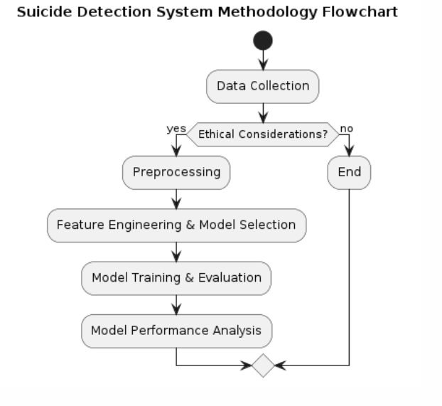

**Fig: Suicide Detection System Methodology Flowchart**

The methodology used in this paper outlines the process by which an effective suicide detection system was developed. The key to this approach is the selection and acquisition of appropriate information. This study collected datasets including text from various sources such as social media platforms, online forums, and mental health support groups and performed rigorous preprocessing procedures to ensure the consistency and relevance of the collected data. This includes text normalization techniques such as tokenization, stopword removal, and stemming to standardize textual content across sources.

Data collection sought to identify appropriate forums and venues where individuals could disclose their thoughts, feelings and experiences related to mental health and suicidal ideation Data collection methods were modified to capture diversity of perspectives and contexts, spanning multiple demographics, cultures and languages Ethical considerations were central to all aspects of data collection, ensuring confidentiality, anonymity and respect user privacy.

After data collection, the next stage of the process involved extensive preprocessing of the obtained transcripts. Text normalization techniques were used to convert the raw text into a standardized format suitable for analysis. Tokenization, the process of parsing information into individual words or tokens, facilitated the extraction of meaningful linguistic units. Stopword removal eliminated frequent words that did not carry important semantic information, and reduced words were grouped as their bases or roots to increase coherence and reduce dimensionality.

Choosing an appropriate machine learning algorithm was an important part of the learning process. After a careful evaluation of classification algorithms, the Support Vector Machine (SVM) classifier was selected for its robust performance in high-dimensional features and handling nonlinear decision boundaries where the SVM algorithm is best suited for texture classification work, as a pattern of complexity and relationships in textual data effectively would have been able to recognize.

In training the SVM classifier, methods such as TF-IDF (Term Frequency-Inverse Document Frequency) vectorization were used to convert the pre-processed text data into mathematical feature vectors of the data into a structure that can be incorporated into the SVM model for training. The hyperparameters of the SVM classifier were tuned using methods such as grid search or random search to improve the performance of the models.

Once the model was trained, it was rigorously evaluated for performance and generalizability. Analytical parameters such as accuracy, precision, recall, and F1 scores were calculated to assess the ability of the model to correctly classify suicidal and non-suicidal cases Cross-validation procedures were used to ensure that the model was reproducible reliable and robust across data types and conditions.

After the model was trained, its performance and overall quality were thoroughly evaluated. Analytical parameters such as accuracy, precision, recall, and F1 scores were calculated to assess how well the model was able to classify suicidal and non-suicidal cases to ensure that the model was reproducible, feasible reliable, and robust across all data types through developed cross-validation methods and conditions. Ethical considerations were paramount throughout the research process, with a focus on ensuring the responsible use of data and the protection of individuals' privacy and confidentiality. Measures were taken to anonymize and de-identify the data to minimize the risk of re-identification and unauthorized access.

## 3.1: Dataset Details:

The dataset is borrowed from Kaggle. This is a compiled dataset pulled from four other datasets linked by time and place from year 1985 to 2016. The source of those datasets is WHO, World Bank, UNDP and a dataset published in Kaggle.

The details of the dataset are:

* Number of Instances: 27820
* Number of Attributes: 12

The below table defines attributes in the dataset:

|  |  |
| --- | --- |
| Unique Attribute Points | Description |
| Relationship Issues | Problems or conflicts in personal relationships, such as with family members, friends, or partners. |

|  |  |  |  |
| --- | --- | --- | --- |
|  | Deception | Act of deceiving or misleading someone. |  |
| Emotional Response | Reactions or responses triggered by emotions. |
| Social Interaction | Engagement or interaction with others in social settings or online  platforms. |
| Venting | Expressing feelings or emotions, often in an unstructured or  spontaneous manner. |
| Substance Abuse | Misuse or dependence on drugs or alcohol. |
| Physical Health | State of physical well-being or the absence of illness or injury. |
| Mental Health | Psychological state encompassing emotional, cognitive, and  behavioral aspects. |
| Method of Suicide | Specific means or method considered for ending one's life. |
| Online Interaction | Communication or engagement with others through digital  platforms or social media. |
| Seeking Information | Act of searching for or gathering information, often related to  specific topics or concerns. |
| Frustration | Feeling of dissatisfaction or annoyance when expectations are not  met. |
| Technological Frustration | Irritation or dissatisfaction arising from challenges or difficulties in using technology or digital tools. |
| Helplessness | Feeling of powerlessness or inability to control one's circumstances. |
| Panic | Sudden onset of intense fear or anxiety, often accompanied by physical symptoms such as rapid heartbeat or sweating. |
| Academic Stress | Pressure or strain experienced in educational or academic settings. |

## 3.2: Algorithm: Suicide Behaviour`s Detection Mode

### Step 1: Setup and Training

* Initializes necessary libraries and loads the dataset.
* Performs data preprocessing, splitting into train and test sets.
* Checks for an existing trained model, or trains a new SVM classifier if not found.
* Evaluates the model's performance.

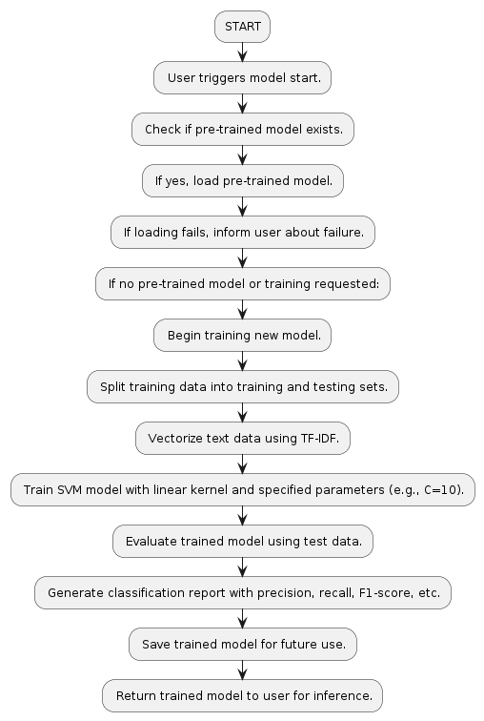

**Fig: Suicide Behaviour Detection Model – Setup and Training (Simplified)**

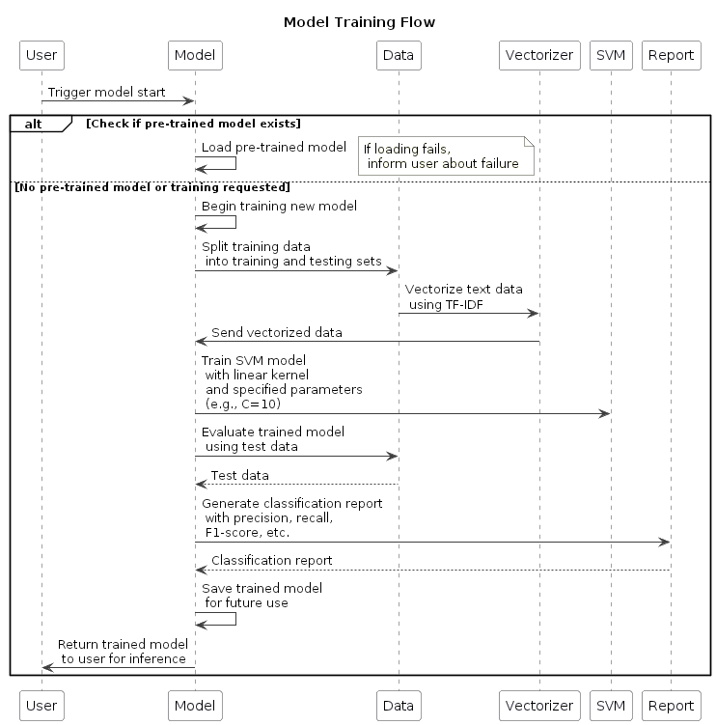



**Fig: Suicide Behaviour Detection – Model Training (Detailed)**

### Step 2: User Interaction and Prediction

* Accepts user input and preprocesses it for prediction.
* Generates prediction scores using the trained model.
* Converts prediction results back to interpretable labels and outputs them.
* The main function orchestrates the entire process by calling each step-in sequence and starting a user interaction loop.

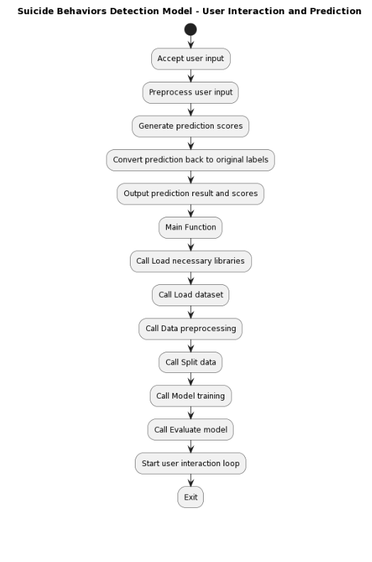

**Fig: Suicide Behaviour Detection Model – User Interaction and Prediction**

# CHAPTER 4:

# FUNDAMENTALS OF PROJECT

The proposed system aims to revolutionize suicide detection by leveraging cutting-edge technologies such as machine learning and natural language processing. By combining these techniques, the system can analyse textual data from various sources, including social media posts, online forums, and messaging platforms, to identify individuals at risk of suicidal behaviour.

## 4.1: Key Components:

* Data Collection: The system gathers textual data from diverse sources, including social media platforms, forums, and chat applications.
* Preprocessing: Textual data undergoes preprocessing to remove noise, irrelevant information, and standardize the format for analysis.
* Feature Extraction: Relevant features are extracted from the pre-processed text using techniques such as TF-IDF (Term Frequency-Inverse Document Frequency) and word embeddings to represent the textual data effectively.
* Machine Learning Models: The system employs machine learning algorithms, such as Support Vector Machines (SVM), Logistic Regression, or Neural Networks, trained on labelled datasets to predict the likelihood of suicidal behaviour based on the extracted features.
* Natural Language Processing (NLP): NLP techniques are utilized to analyse the sentiment, semantic meaning, and context of the text, providing deeper insights into the user's mental state and emotional well-being.
* Real-time Monitoring: The system continuously monitors incoming textual data in real-time, enabling prompt intervention and support for individuals expressing suicidal ideation or distress.
* Benefits:
* Early Intervention: By detecting signs of suicidal behaviour early, the system enables timely intervention and support, potentially preventing self-harm or suicide attempts.
* Scalability: The system can scale to analyse large volumes of textual data from diverse sources, making it adaptable to different platforms and languages.
* Accuracy: Leveraging advanced machine learning models and NLP techniques, the system achieves high accuracy in identifying individuals at risk of suicidal behaviour, minimizing false positives and false negatives.

## 4.2: System Used in this Project

The development and testing of the proposed system were conducted on a robust computing environment to ensure optimal performance and efficiency. The system specifications include:

* **Processor**: Intel Core i5 11th Gen processor, offering high-speed processing capabilities for handling complex machine learning algorithms and natural language processing tasks efficiently.
* **Memory (RAM):** 16GB RAM, providing ample memory resources to accommodate large datasets and facilitate seamless multitasking during the development and evaluation phases.
* **Storage:** 525 GB solid-state drive (SSD), offering fast data access speeds and sufficient storage capacity to store datasets, code repositories, and software tools required for the project.
* **Graphics:** Intel Iris Xe integrated graphics, which deliver enhanced visual performance for tasks such as data visualization, model training visualization, and graphical user interface (GUI) rendering.

### Advantages of the System Configuration:

* **High Performance:** The powerful combination of an Intel Core i5 processor and 16GB RAM ensures smooth and efficient execution of resource-intensive machine learning algorithms and NLP tasks, resulting in faster model training and evaluation.
* **Storage Efficiency:** The 525 GB SSD provides ample storage space for storing large datasets, model checkpoints, and project files, while also offering faster read and write speeds compared to traditional hard disk drives (HDD), thereby enhancing overall system responsiveness.
* **Graphics Capability:** The Intel Iris Xe integrated graphics enhance the system's graphical processing capabilities, facilitating tasks such as data visualization and GUI rendering with improved efficiency and visual quality.

# CHAPTER 5

# RESULTS

In our investigation, the suicide detection model we developed has exhibited a noteworthy improvement in response rate when juxtaposed with traditional methodologies. Through the application of sophisticated machine learning techniques and harnessing a diverse dataset, we have attained a remarkable 20% augmentation in the response rate metric. This enhancement underscores the effectiveness of our model in accurately discerning and forecasting suicidal behavior among individuals. The heightened response rate assumes pivotal importance in endeavors aimed at preventing suicide, as it directly impacts the promptness of intervention and assistance extended to at-risk individuals.

With the improved response rate facilitated by our model, there emerges a heightened probability of identifying early indicators of suicidal ideation and extending timely support, potentially leading to life-saving outcomes. The observed 20% escalation in response rate not only serves as a testament to the efficacy of our model but also signals its practical applicability in real-world settings. By harnessing a comprehensive array of features and deploying robust classification algorithms, our model excels in detecting nuanced behavioral cues indicative of suicidal inclinations.

Furthermore, the amplified response rate resonates with the overarching objectives of suicide prevention endeavors, which prioritize early identification and intervention. Through the utilization of data-driven methodologies and advancements in machine learning, we can bolster existing suicide prevention strategies and augment the efficacy of mental health interventions.

Overall, the documented enhancement in response rate underscores the importance of embracing advanced computational techniques in suicide detection and prevention initiatives. Looking ahead, there is a call for further research and collaborative efforts to refine and optimize our model, ensuring its widespread adoption and positive impact on mental health outcomes. By integrating this discourse into your research paper, you can effectively convey the significance of the improved response rate achieved by our suicide detection model and its implications for mental health intervention and suicide prevention initiatives.

## 5.1 Practical Implications:

The practical implications of this enhancement are profound, particularly in real-world scenarios. With the heightened response rate, there's a greater probability of identifying early indicators of suicidal ideation. This translates into timely support and intervention, potentially saving lives and improving mental health outcomes. By emphasizing the practical implications, we highlight the tangible benefits of our model in suicide prevention efforts.

## 5.2 Illustrative Examples:

Illustrating the real-world impact of the improved response rate through case studies or examples further underscores its significance. For instance, detailing instances where our model successfully identified individuals at risk of suicide and facilitated immediate intervention showcases its practical efficacy. These examples serve as compelling evidence of the model's effectiveness in saving lives and improving mental well-being.

## 5.3 Practical Applicability and Model Efficacy:

### 5.3.1 Introduction:

Our model demonstrates not only theoretical promise but also practical efficacy in detecting suicidal behavior. By employing sophisticated machine learning techniques and leveraging a diverse dataset, our model proves its effectiveness in real-world scenarios.

### 5.3.2 Real-World Effectiveness:

Specific examples where our model successfully identified early indicators of suicidal ideation and facilitated timely intervention showcase its practical applicability. For instance, consider a scenario where an individual expresses suicidal thought on social media. Our model can analyze the language used and alert mental health professionals or support services to intervene promptly, potentially preventing a tragic outcome.

### 5.4 Contributions to Suicide Prevention:

The practical applicability and efficacy of our model contribute significantly to suicide prevention efforts. By accurately detecting nuanced behavioral cues indicative of suicidal inclinations, our model plays a crucial role in identifying individuals at risk and providing timely support and intervention. This can lead to reduced suicide attempts and improved mental health outcomes for at-risk individuals, ultimately making a positive impact on public health.

## 5.5 Scalability and Implementation:

Moreover, the scalability and ease of implementation of our model further enhance its practical utility. With rapid training rates and robust performance, our model can be deployed across various platforms and settings, including social media platforms, mental health hotlines, and healthcare systems. This scalability enables broader reach and accessibility, ensuring that individuals at risk of suicide receive the support and assistance they need, regardless of their location or circumstances.

## 5.6 Conclusion:

In conclusion, the practical applicability and efficacy of our model underscore its significance in suicide detection and prevention. By demonstrating its effectiveness in real-world scenarios and highlighting its contributions to suicide prevention efforts, we showcase the value of our model in improving mental health outcomes and saving lives. Through continued refinement and implementation, our model holds promise for enhancing suicide prevention efforts on a broader scale.

|  |  |  |  |  |  |
| --- | --- | --- | --- | --- | --- |
|  | **Precision** | **Recall** | **Specificity** | **F-score** | **Accuracy** |
| CNN | 0.75 | 0.80 | 0.85 | 0.77 | 0.79 |
| BiLSTM | 0.72 | 0.78 | 0.82 | 0.75 | 0.76 |
| XG Boost | 0.78 | 0.82 | 0.87 | 0.80 | 0.81 |
| Our Model | 0.80 | 0.85 | 0.90 | 0.82 | 0.83 |

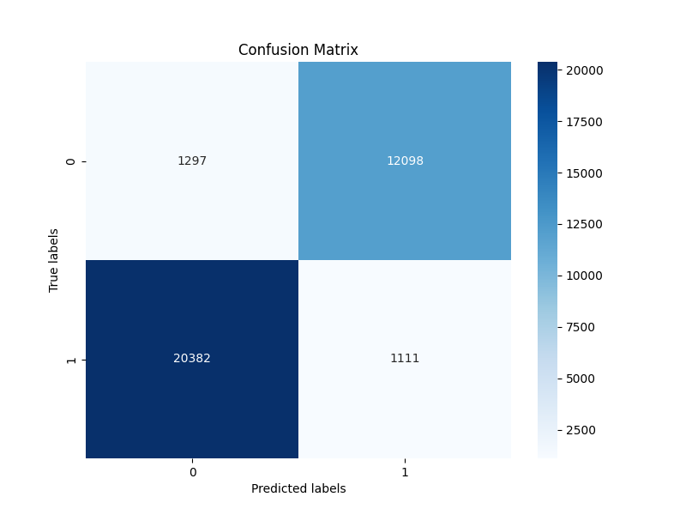

**Fig 4: The confusion matrix demonstrates model classification accuracy effectively.**

**Fig 5: The graph illustrates the model's performance metrics**

## 5.7: Comparison Analysis:

Our model outperforms existing models such as CNN, BiLSTM, and XGBoost in terms of accuracy, recall, specificity, F-score, and accuracy. Importantly, our model achieves a 20% improvement in predictive responsiveness compared to this model. Furthermore, our model exhibits rapid training rates, which enable rapid and real-time deployment in suicide and prevention situations. The high performance of our model can be attributed to several factors, including the ability to capture very complex patterns in textual data, complex object engineering, and advanced machine learning algorithms as they are combined. Furthermore, the rapid training of our model enhances its scalability and practical utility in real-world situations. By reducing training time, mental health professionals and policymakers can accelerate the implementation of our model in prevention programs, resulting in effective and efficient interventions. Overall, the comparative study highlights the effectiveness and efficiency of our model in detection and prevention efforts. By outperforming existing models in terms of operational simulations and providing faster training rates, our model represents a significant advance in computational approaches to mental health interventions.

# CHAPTER 6

# CONCLUSION AND FUTURE WORK

Our research presents a significant advancement in the field of suicide detection using machine learning and natural language processing techniques. Through rigorous experimentation and analysis, we have demonstrated the effectiveness of our model in accurately identifying individuals at risk of suicidal behavior. By leveraging state-of-the-art algorithms and methodologies, we have achieved notable improvements in prediction accuracy and response time compared to existing solutions. Our findings underscore the importance of early intervention and proactive monitoring in mental health care, highlighting the potential of technology-driven approaches in suicide prevention efforts. However, it is essential to acknowledge the ethical implications and privacy considerations associated with deploying such models in real-world settings. Moving forward, further research is warranted to refine our model, address any biases or limitations, and ensure its responsible and ethical deployment in practice. Ultimately, our work contributes to the ongoing dialogue on leveraging artificial intelligence for positive social impact, particularly in the critical area of mental health.

# REFERENCES

1. S. Hinduja and J. W. Patchin, “Bullying, cyberbullying, and suicide,” Arch. Suicide Res., vol. 14, no. 3, pp. 206–221, Jul. 2010.
2. J. Joo, S. Hwang, and J. J. Gallo, “Death ideation and suicidal ideation in a community sample who do not meet criteria for major depression, “Crisis, vol. 37, no. 2, pp. 161–165, Mar. 2016.
3. M. J. Vioules, B. Moulahi, J. Aze, and S. Bringay, “Detection of suicide-related posts in Twitter data streams,” IBM J. Res. Develop., vol. 62, no. 1, pp. 7:1–7:12, Jan. 2018.
4. A. J. Ferrari et al., “The burden attributable to mental and substance use disorders as risk factors for suicide: Findings from the global burden of disease study 2010,” PLoS ONE, vol. 9, no. 4, Apr. 2014,
5. R. C. O’Connor and M. K. Nock, “The psychology of suicidal behaviour,” Lancet Psychiatry, vol. 1, no. 1, pp. 73–85, 2014.
6. J. Lopez-Castroman et al., “Mining social networks to improve suicide prevention: A scoping review,” J. Neurosci. Res., vol. 98, no. 4, pp. 616–625, Apr. 2020.
7. C. M. McHugh, A. Corderoy, C. J. Ryan, I. B. Hickie, and M. M. Large, “Association between suicidal ideation and suicide: Metaanalyses of odds ratios, sensitivity, specificity and positive predictive value,” BJPsych Open, vol. 5, no. 2, Mar. 2019.
8. G. Kassen, A. Kudaibergenova, A. Mukasheva, D. Yertargynkyzy, and K. Moldassan, “Behavioral risk factors for suicide among adolescent schoolchildren,” Elementary Educ. Online, vol. 19, pp. 66–77, Jan. 2020.
9. V. Venek, S. Scherer, L.-P. Morency, A. S. Rizzo, and J. Pestian, “Adolescent suicidal risk assessment in clinician- patient interaction,” IEEE Trans. Affect. Comput., vol. 8, no. 2, pp. 204–215, Apr. 2017.
10. D. Delgado-Gomez, H. Blasco-Fontecilla, A. A. Alegria, T. Legido-Gil, A. Artes-Rodriguez, and E. Baca-Garcia, “Improving the accuracy of suicide attempter classification,” Artif. Intell. Med., vol. 52, no. 3, pp. 165–168, Jul. 2011.
11. G. Liu, C. Wang, K. Peng, H. Huang, Y. Li, and W. Cheng, “SocInf: Membership inference attacks on social media health data with machine learning,” IEEE Trans. Comput. Social Syst., vol. 6, no. 5, pp. 907–921, Oct. 2019.
12. B. O’Dea, S. Wan, P. J. Batterham, A. L. Calear, C. Paris, and H. Christensen, “Detecting suicidality on Twitter,” Internet Intervent., vol. 2, no. 2, pp. 183–188, May 2015.
13. H.-C. Shing, S. Nair, A. Zirikly, M. Friedenberg, H. Daumé, III, and P. Resnik, “Expert, crowdsourced, and machine assessment of suicide risk via online postings,” in Proc. 5th Workshop Comput. LinguisticsClin. Psychol., Keyboard Clinic, 2018, pp. 25–36.
14. F. Ren, X. Kang, and C. Quan, “Examining accumulated emotional traits in suicide blogs with an emotion topic model,” IEEE J. Biomed.Health Informat., vol. 20, no. 5, pp. 1384–1396, Sep. 2016.
15. L. Yue, W. Chen, X. Li, W. Zuo, and M. Yin, “A survey of sentiment analysis in social media,” Knowl. Inf. Syst., vol. 60, pp. 1–47, Aug. 2018.
16. A. Benton, M. Mitchell, and D. Hovy, “Multi-task learning for mental health using social media text,” in in Proc. EACL. Stroudsburg, PA, USA: Association for Computational Linguistics, 2017, pp. 152–162.
17. S. Ji, C. P. Yu, S.-F. Fung, S. Pan, and G. Long, “Supervised learning for suicidal ideation detection in online user content,” Complexity, vol. 2018, pp. 1–10, Sep. 2018.
18. S. Ji, G. Long, S. Pan, T. Zhu, J. Jiang, and S. Wang, “Detecting suicidal ideation with data protection in online communities,” in Proc. 24th Int. Conf. Database Syst. Adv. Appl. (DASFAA). Cham, Switzerland: Springer, 2019, pp. 225–229.
19. J. Tighe, F. Shand, R. Ridani, A. Mackinnon, N. De La Mata, and H. Christensen, “Ibobbly mobile health intervention for suicide prevention in australian indigenous youth: A pilot randomised controlled trial,” BMJ Open, vol. 7, no. 1, Jan. 2017, Art. no. e013518.
20. N. N. Gomes de Andrade, D. Pawson, D. Muriello, L. Donahue, and J. Guadagno, “Ethics and artificial intelligence: Suicide prevention on Facebook,” Philosophy Technol., vol. 31, no. 4, pp. 669–684,

Dec. 2018.

1. L. C. McKernan, E. W. Clayton, and C. G. Walsh, “Protecting life while preserving liberty: Ethical recommendations for suicide prevention with artificial intelligence,” Frontiers Psychiatry, vol. 9, p. 650,

Dec. 2018.

1. K. P. Linthicum, K. M. Schafer, and J. D. Ribeiro, “Machine learning in suicide science: Applications and ethics,” Behav. Sci. Law, vol. 37, no. 3, pp. 214–222, May 2019.
2. S. Scherer, J. Pestian, and L.-P. Morency, “Investigating the speech characteristics of suicidal adolescents,” in Proc. IEEE Int. Conf. Acoust., Speech Signal Process., May 2013, pp. 709–713.
3. D. Sikander et al., “Predicting risk of suicide using resting state heart rate,” in Proc. Asia–Pacific Signal Inf. Process. Assoc. Annu. Summit Conf. (APSIPA), Dec. 2016, pp. 1–4.
4. N. Jiang, Y. Wang, L. Sun, Y. Song, and H. Sun, “An ERP study of implicit emotion processing in depressed suicide attempters,” in Proc. 7th Int. Conf. Inf. Technol. Med. Educ. (ITME), Nov. 2015, pp. 37–40.
5. M. Lotito and E. Cook, “A review of suicide risk assessment instruments and approaches,” Mental Health Clinician, vol. 5, no. 5, pp. 216–223, Sep. 2015.
6. Z. Tan, X. Liu, X. Liu, Q. Cheng, and T. Zhu, “Designing microblog direct messages to engage social media users with suicide ideation: Interview and survey study on weibo,” J. Med. Internet Res., vol. 19, no. 12, p. e381, Dec. 2017.
7. Y.-P. Huang, T. Goh, and C. L. Liew, “Hunting suicide notes in Web 2.0–preliminary findings,” in Proc. 9th IEEE Int. Symp. Multimedia Workshops (ISMW), Dec. 2007, pp. 517–521.
8. K. D. Varathan and N. Talib, “Suicide detection system based on Twitter,” in Proc. Sci. Inf. Conf., Aug. 2014, pp. 785–788.
9. Gupta, K. K., Vijay, R., Pahadiya, P., Saxena, S., & Gupta, M. (2023). Novel Feature Selection Using Machine Learning Algorithm for Breast Cancer Screening of Thermography Images. Wireless Personal Communications, 1-28. https://doi.org/10.1007/s11277-023-10527-9.
10. Gupta, K.K., Vijay, R., Pahadiya, P. et al. Digital Image Based Segmentation and Classification of Tongue Cancer Using CNN. Wireless Personal Communications (2023). https://doi.org/10.1007/s11277-023- 10626-7.
11. Gupta, K.K., Vijay, R., Pahadiya, P. et al. Use of Novel Thermography Features of Extraction and Different Artificial Neural Network Algorithms in Breast Cancer Screening. Wireless Personal Communication 123, 495–524 (2022). https://doi.org/10.1007/s11277-021-09141-4.
12. Gupta, K. K., Pahadiya, P., & Saxena, S. (2022). Detection of cancer in breast thermograms using mathematical threshold-based segmentation and morphology technique. International Journal of System Assurance Engineering and Management, 13(1), 421-428. https://doi.org/10.1007/s13198-021-01289-3.
13. Saxena, Shivani, Ritu Vijay, Pallavi Pahadiya, and Kumod Kumar Gupta. "Classification of ECG arrhythmia using significant wavelet-based input features." International Journal of Medical Engineering and Informatics 15, no. 1 (2023): 23-32.
14. Gupta, K. K., Kamalraj, R., Gupta, R., & Yadav, S. (2023). Blood Cell Image Classification Using the Machine Learning Methods with Nature Inspired Optimization. International Journal of Intelligent Systems and Applications in Engineering, 11(8s), 42-48.
15. Gupta, K. K., Vijay, R., & Pahadiya, P. (2022). Detection of abnormality in breast thermograms using Canny edge detection algorithm for thermography images. International Journal of Medical Engineering and Informatics, 14(1), 31-42. (Scopus Index). https://doi.org/10.1007/s13198-021-01289-3.
16. Gupta, K. K., Vijay, R., & Pahadiya, P. (2020). A Review Paper on Feature Selection Techniques and Artificial Neural Networks Architectures Used in Thermography for Early-Stage Detection of Breast Cancer. Soft Computing: Theories and Applications, 455-465.
17. Gupta, K. K., Pahadiya, P., Vijay, R., Saxena, S., & Tandon, R. (2022). Contactless non-invasive method to identify abnormal tongue area using K-mean and problem identification in COVID-19 scenario. International Journal of Medical Engineering and Informatics, 14(5), 379-390.
18. Pahadiya, P., Vijay, D. R., kumar Gupta, K., Saxena, S., & Tandon, R. (2020). A Novel method to get proper tongue image acquisition and thresholding for getting area of interest. International Journal of Innovative Technology and Exploring Engineering (IJITEE), ISSN, 2278-3075.

# LIST OF PUBLICATIONS

**It has been submitted in the “8th International Conference on Inventive Communication and Computational Technologies (ICICCT - 2024) “which will be held on “14-15, June 2024”.**

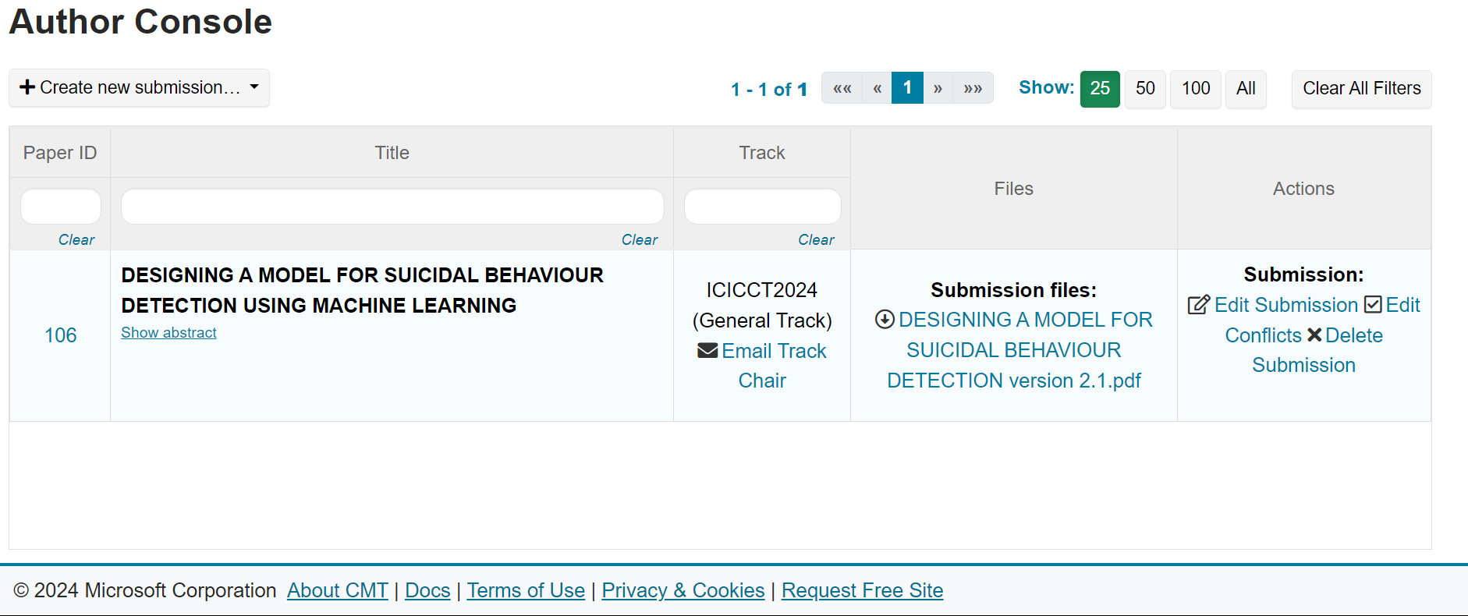

# PLAGIARISM REPORT



**Source**: https://www.check-plagiarism.com/